Anomaly Detection Score White Paper

Initial feature set:

total_rcvd_value: total value received for all history

total_sent_value: total value sent for all history

total_balance: total balance over all history (avg_sent_value-avg_rcvd_value)

total_rcvd_count: total number of TXs received for all history

total_sent_count: total number of TXs sent for all history

avg_rcvd_value_per_block: historical avg value received per block

avg_sent_value_per_block: historical avg value sent per block

avg_rcvd_count_per_block: historical avg # TXs received per block

avg_sent_count_per_block: historical avg # TXs sent per block

max_rcvd_value_per_block: historical max value received per block

max_sent_value_per_block: historical max value sent per block

max_rcvd_count_per_block: historical max # TXs received per block

max_sent_count_per_block: historical max # TXs sent per block

avg_sent_count_per_sec: historical avg # TXs sent per second

avg_rcvd_count_per_sec: historical avg # TXs received per second

avg_rcvd_value_per_sec: historical avg value received per second

avg_sent_value_per_sec: historical avg value sent per second

max_sent_count_per_sec: historical max # TXs sent per second

max_rcvd_count_per_sec: historical max # TXs received per second

max_rcvd_value_per_sec: historical max value received per second

max_sent_value_per_sec: historical max value sent per second

I analyzed all of the above variables for collinearity by looking at their correlation matrix. Out of 441 possible relationships, I did not find any that were correlated over 90%.

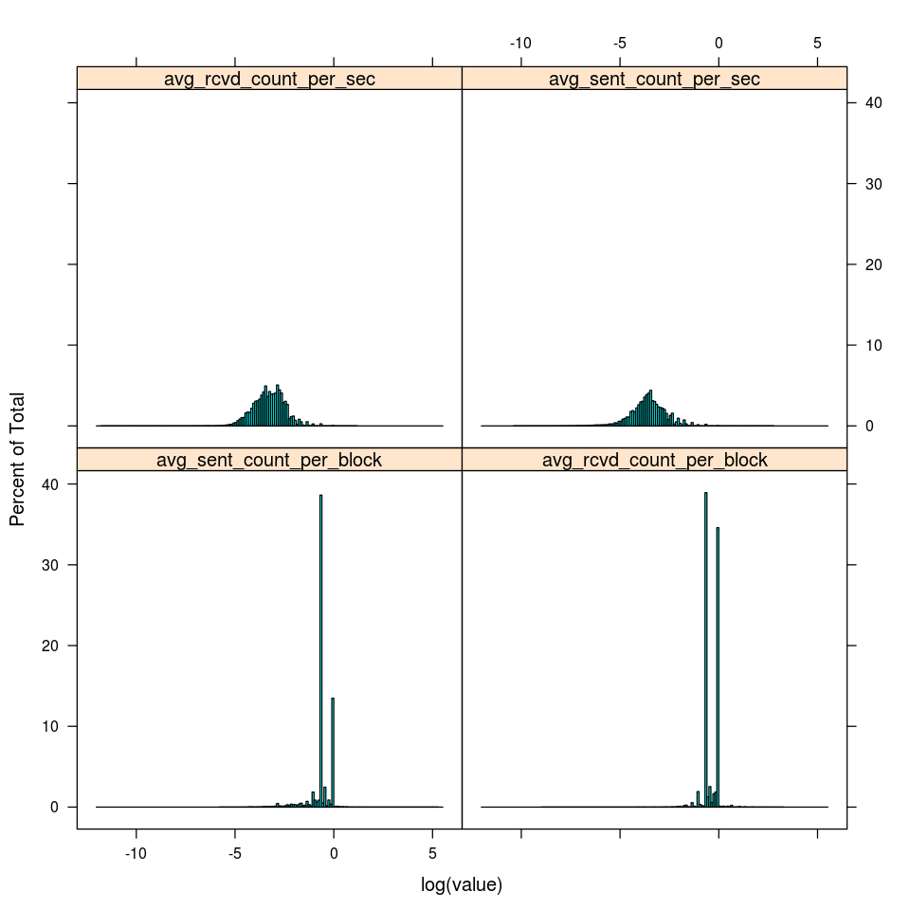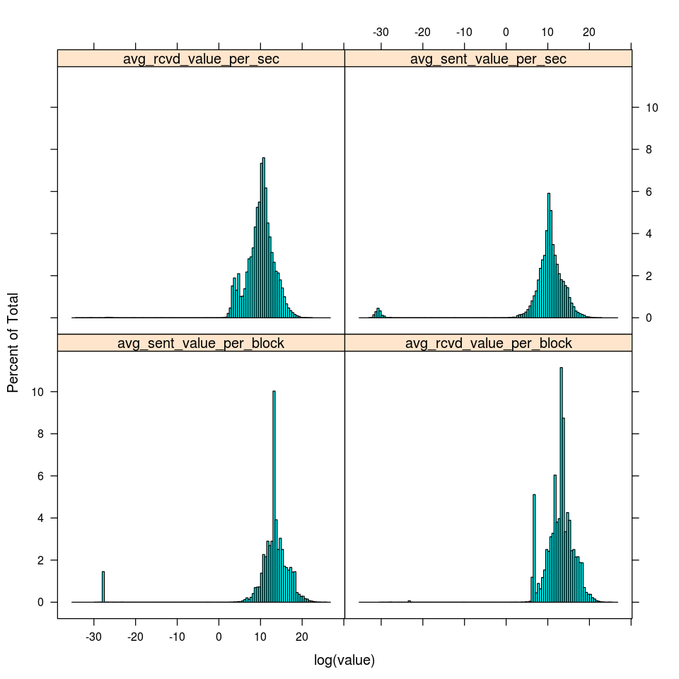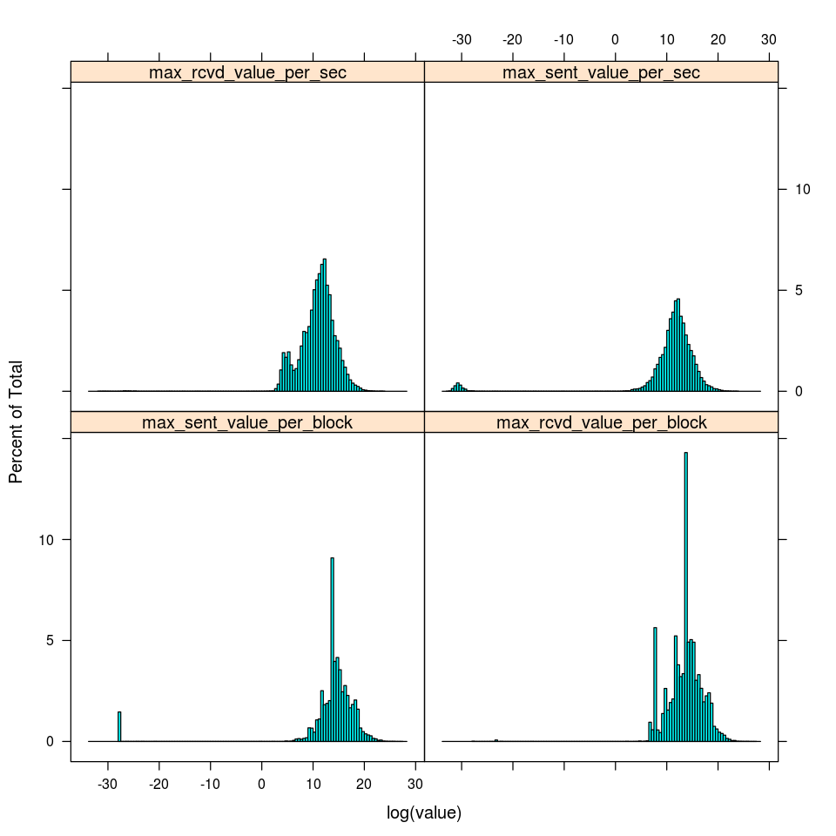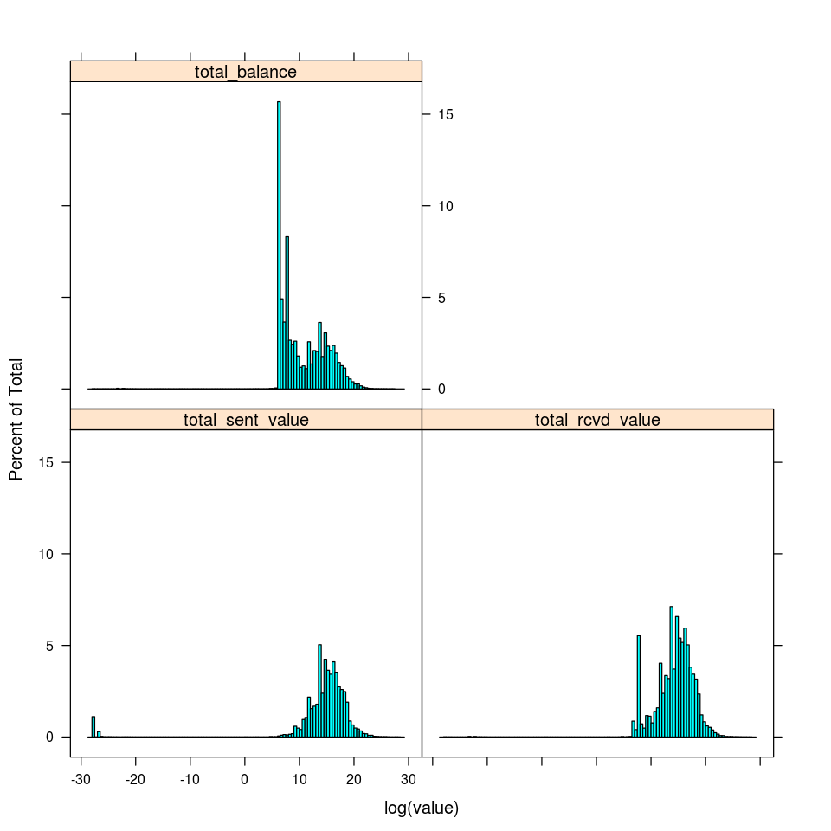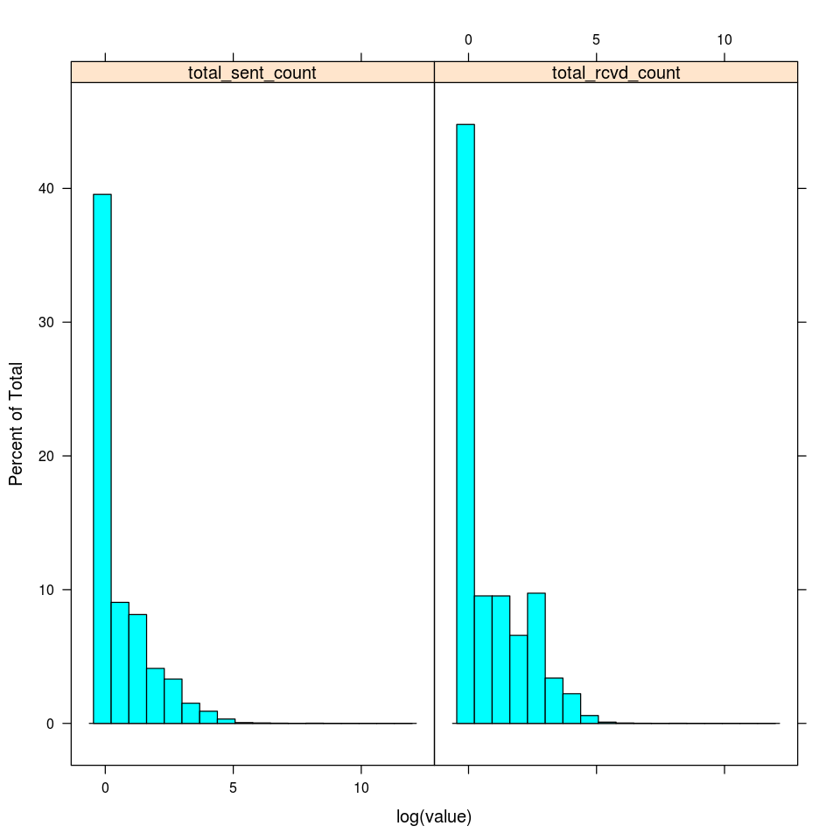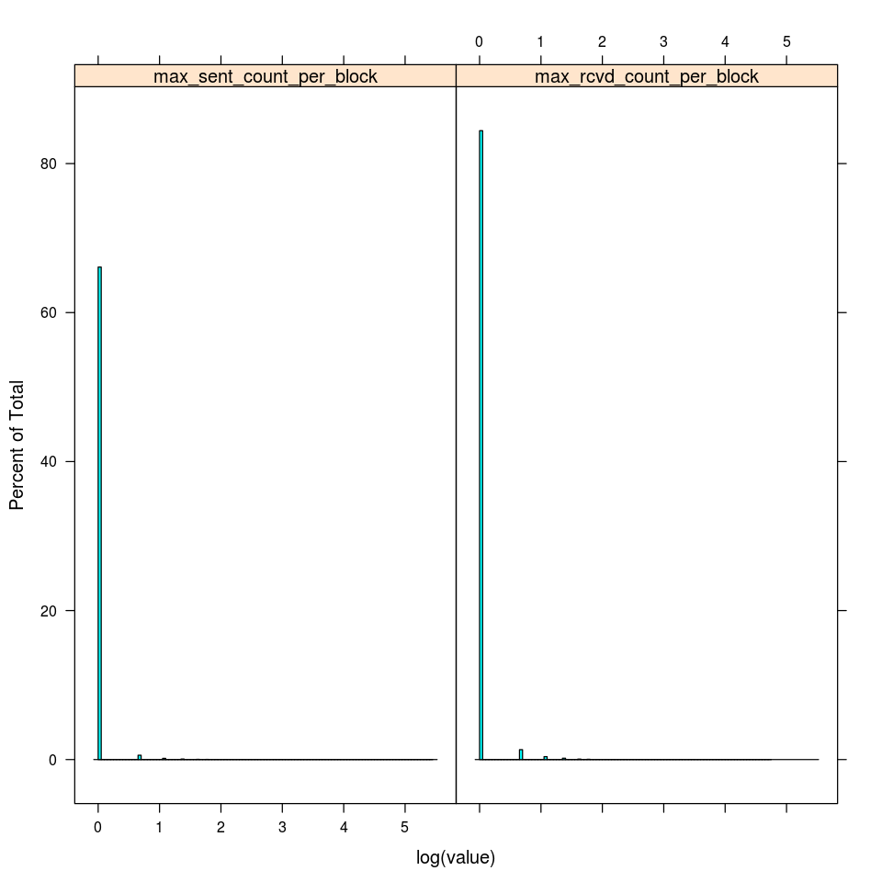

We can see that in general, the variables involving averages/maxima over blocks are much further from normal than the variables involving averages. Therefore I decided to exclude all aggregate variables over blocks in favor of aggregations per second.

Finally, I ran a GMM for k={2,4,6,8,10,12,14,16,18,20} and observed the log likelihood. I found the following curve for the log likelihood:

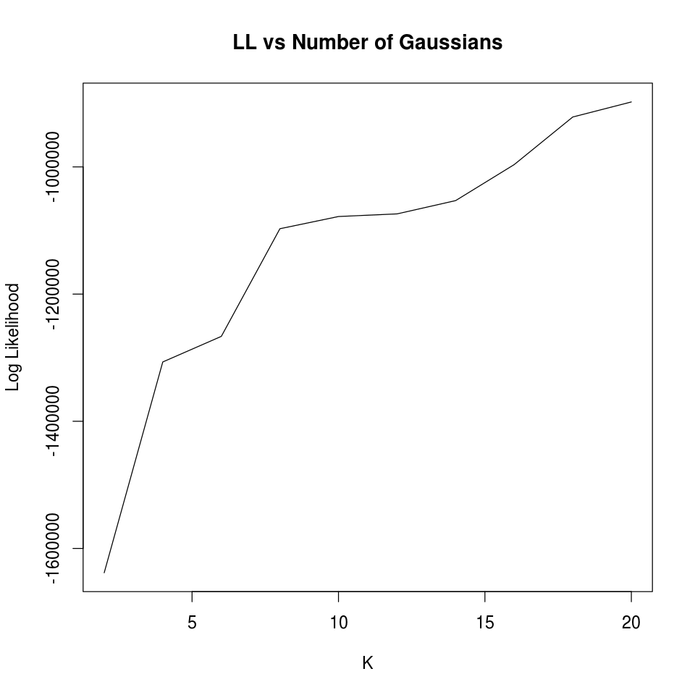

There appears to be a significant “elbow” in this curve at K=8; therefore I will pick K=8 as the number of independent gaussians for this model.